**FINAL PROJECT I**

**REPORT ON SWIGGY- PRE AND POST DIWALI SALES DATA**

**Submitted by: Mansi (3569, New Delhi)**

The data provided by Swiggy has been analysed on MySQL workbench 8.0 as a part of Final Project of the SQL module.

The two big data sets namely “pre” and “post” have been imported into the “finalproject1” schema using command prompt instead of Table import wizard for faster working.

Multiple queries using functions like count(), avg(), max(), group by, order by, distinct, between have been run to obtain some useful results. Other concepts like table alias, inner join, wildcards have also been put into use. The following are the observations obtained after analysis.

1. City wise distribution of the maximum orders placed has been observed.

It is observed that city with codes 7, 10459 and 18 were the ones with maximum orders placed. City 18 performed better than city 10459 post Diwali. However, city 7 remained at top.

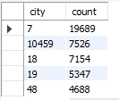 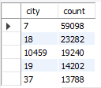

Pre Diwali Post Diwali

1. The most sold category has been compared pre and post Diwali.

It has been observed that sweets remained the choice of people both pre and post Diwali followed by snacks.

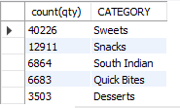 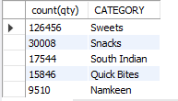

Pre Diwali Post Diwali

1. Item wise sales

It has been found out that “Masala Dosa”, “Samosa” and “Gulab Jamun” are the items with top 3 sales item wise both pre and post Diwali.

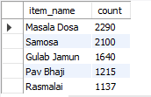 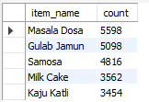

Pre Diwali Post Diwali

1. On comparing the average item_gmv before and after Diwali, we can conclude that the sales shot up right after Diwali.

The avg(item_gmv) pre Diwali being 224 and that post Diwali being 311, where “gmv” denotes the gross merchandise value to indicate thetotal sales dollar value for a particular merchandise and here we have considered average value.



1. Hour wise distribution. Hours of the day are divided into 4 slabs of 6 hours each and analysis is done on sales reported in these different slabs pre and post Diwali.

It can be said that in the time slot between 16-22, maximum sales have been achieved.



1. Day wise analysis on the maximum says tells us the days contributing to the maximum sales with respect to Diwali. A trend can be observed which shows that sales shot up right before Diwali.

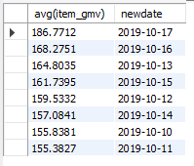 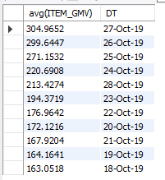

Pre Diwali Post Diwali

1. Outlet wise orders have been analysed to find the outlets and their respective cities with the maximum number of orders placed.

Haldiram’s with city code 81 topped the list with almost double of the second scorer pre Diwali as shown.

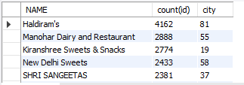

1. Another analysis on the names of outlets show us that no two cities have the same name of outlets.

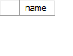

1. A city wise analysis reported that 4 cities with code mentioned below appeared as new comers post Diwali i.e. either their pre Diwali data is unavailable or there were no sales in those cities by Swiggy.

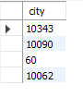 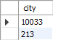

City codes whose data vanished post Diwali.

City codes that appeared post Diwali in data

1. This can also be observed from the data that same items having different item name entries are present which leads to another ambiguity in the data. The chances of wrong sales or order calculation increases due to items having similar names.

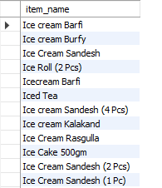

1. Category wise sales(item_gsv) analysis presented that Haldiram’s special thali brought the maximum revenue followed closely by dry fruits during this period of time.

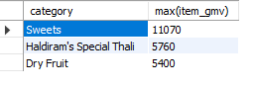

1. A wholesome analysis made on the outlets to find out the most popular entries pre Diwali depicted the top 3 outlets with more than 5000 entries.

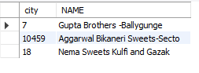

1. Item with minimum sales is found out to know the least revenue generating item.

 

Pre Diwali Post Diwali

1. We also know the outlet with maximum number of products offering most variety to the customers.

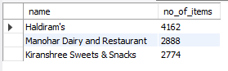 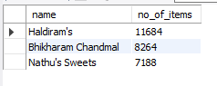

Pre Diwali Post Diwali

**Results and discussion:**

From the above observations and analysis, one can conclude various changes in business planning and execution.

* The city codes with maximum number of orders placed can be facilitated with more number of delivery agents employed in the area.
* The outlet performing the best in terms of overall sales, category wise sales and item wise sales can be facilitated with different attractive schemes, coupons, sales and incentives.
* The pre and post Diwali comparison provides us with the market trend during that interval of time which can be utilized to enhance the sales for coming years.
* Apart from sales, the number of site visits per customer also matter for an online portal which can be increased by studying these changes in number of orders placed in directly.
* Day wise sales comparison also tell us about the trend observed among customers and also their inclination towards buying costlier food items.